**Image Viewer System Documentation**

Home:



In Images menu, you can import new images and words:

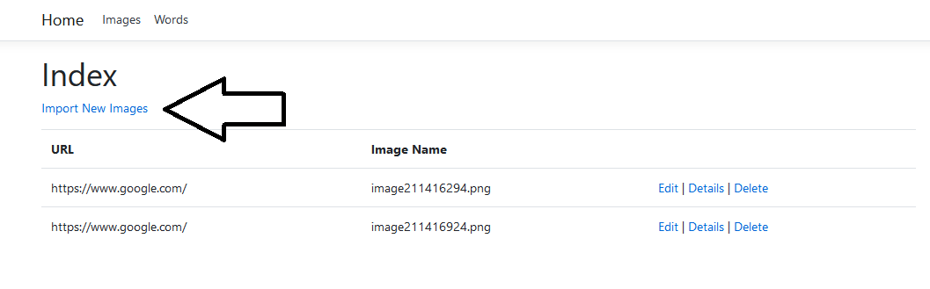

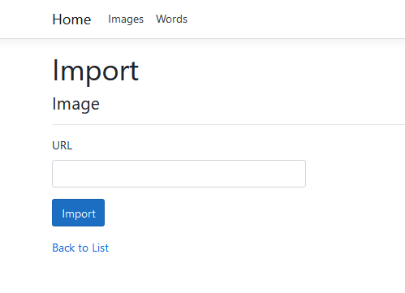

After imported, images will appear on index list of images, and words will appear on Words menu

Details of an image:

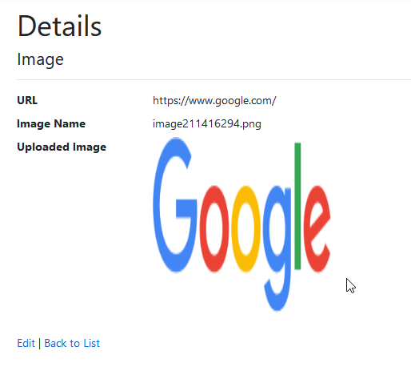

List of words:

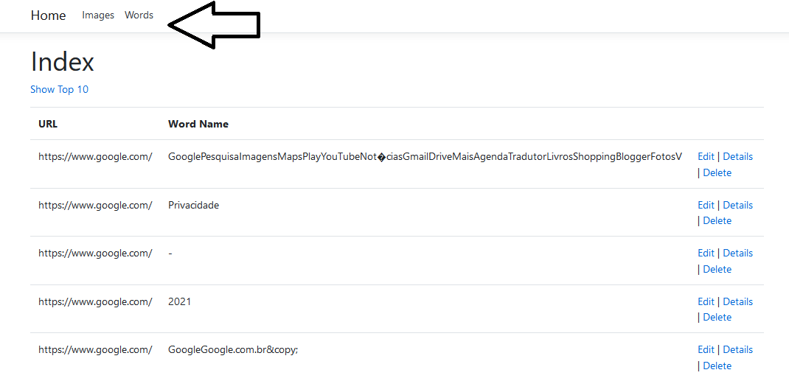

To show the top ten most occuring words, click on “Show Top 10” link:

